ASSIGNMENT-5

**1) What is meant by Docker**

**Docker image**

**Docker Container**

**Docker file**

**Docker –** It is a container which contain software, Operating system and libraries.

**Docker image -** A Docker image is a lightweight, standalone that includes everything needed to run an application, including the code, runtime, libraries, tools, and system dependencies

**Docker Container -** Docker Container: A Docker container is a running instance of a Docker image. It is a lightweight and isolated runtime environment that encapsulates an application and its dependencies.

**Docker files** - are written using a simple syntax and a set of predefined instructions provided by Docker. By using a Docker file, you can automate the image creation process and ensure consistency across different environments and deployments.

2) Go through the attached paper using this URL and test calculator using PYUNIT

https://python.plainenglish.io/python-unittest-how-to-test-your-program-the-right-way-

30f1a459d9d1

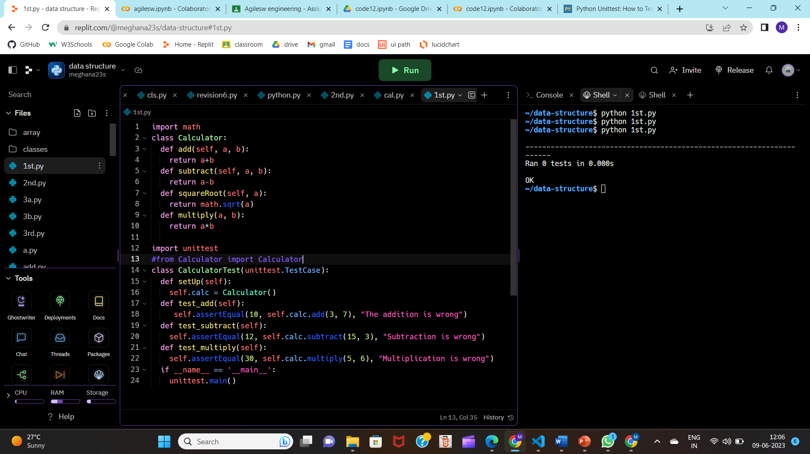

**3) Write Python Program and store it in GIT/GitHub**

[**https://github.com/meghanasiddu23/Agile-software**](https://github.com/meghanasiddu23/Agile-software)

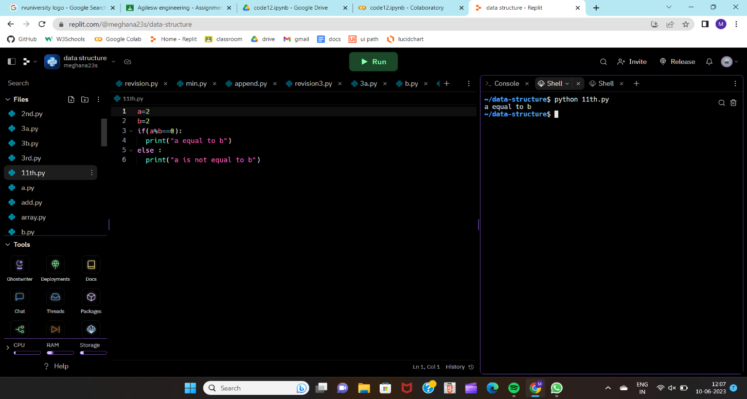

**4) Explain how tool maven works.**

Maven is a popular build automation and dependency management tool primarily used in Java projects. It simplifies the project build process and handles tasks such as compilation, testing, packaging, and deployment.

**5) Explain how Jenkins can be used as an orchestration tool**

Jenkins is a widely used open-source automation server that can be leveraged as an orchestration tool in various software development processes